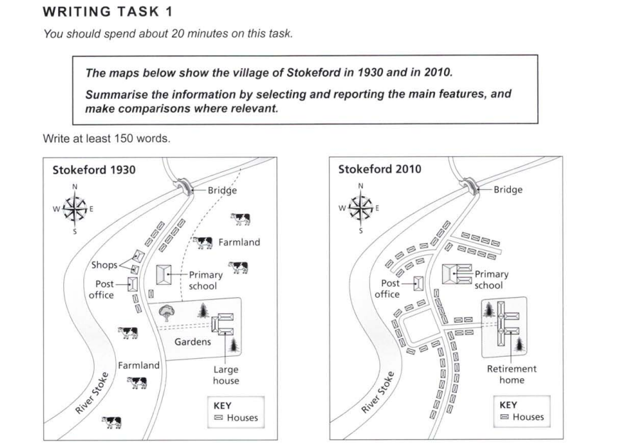

Essay Response:

The given maps depict the area of Stokeford at two different points of time – in 1930, and in 2010. While River Stoke has not changed its path through these years, there are several observable changes along the main road that have changed the image of the village into a small town.

In 1930, there were only about 10 houses in Stokeford, with one large house that had vast gardens around it. On the other side of the main road, there were stretches of farmland that overlooked the river. The village had a few amenities, like a post office, a few shops, and a primary school, all located near the residential area.

By 2010, the elementary school was extended to have two more blocks, and the large house was replaced by a home for the elderly. Quite noticeably, the number of houses in the area more than tripled over the past eighty years, lining the main road, along with an extra drive that leads to more homes built by the river’s shores. These homes were built on land that were once farmland, while some others are situated in the areas where shops once were.

Interestingly, no change was made to the bridge at the northern end of Stokeford, and the width of the main road has stayed the same.